Tables

Create a table
You can create and format a table, to visually group and analyze data.
- Select a cell within your data.
- Select Home > Format as Table.
- Choose a style for your table.
- In the Format as Table dialog box, set your cell range.
- Mark if your table has headers.
- Select OK.
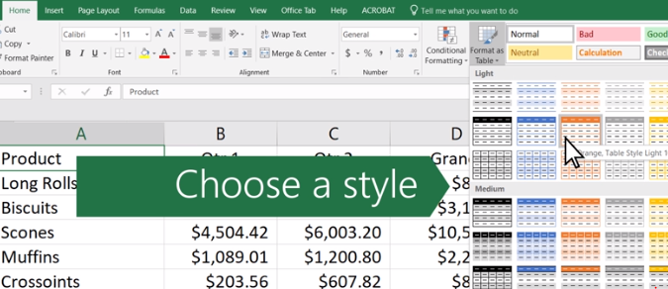

Sort data in a table
Sorting is one of the most common tools for data management. In Excel, you can sort your table by one or more columns, by ascending or descending order, or do a custom sort.
Before sorting a table:
- Make sure that there are no empty rows or columns in the table.
- Get table headers into one row across the top.
- Make sure there is at least one empty column between the table you want to sort, and other information on the worksheet not in that table.
Sort the table
- Select a cell within the data.
- Select Home > Sort & Filter.
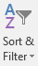
Or, select Data > Sort.
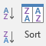
- Select an option:
  - Sort A to Z - sorts the selected column in an ascending order.
  - Sort Z to A - sorts the selected column in a descending order.
  - Custom Sort - sorts data in multiple columns by applying different sort criteria.
For a Custom Sort:
- Select Custom Sort.
- Select Add Level.
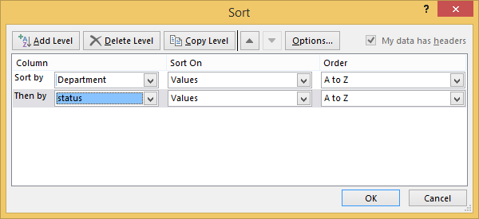
- For Column, select the column you want to Sort by from the drop-down, and then select the second column you Then by want to sort. For example, Sort by Department and Then by Status.
- For Sort On, select Values.
- For Order, select an option, like A to Z, Smallest to Largest, or Largest to Smallest.
- For each additional column that you want to sort by, repeat steps 2-5.
Note: To delete a level, select Delete Level.
- Check the My data has headers checkbox, if your data has a header row.
- Select OK.

Filter data in a range or table
Use filters to temporarily hide some of the data in a table, so you can focus on the data you want to see.
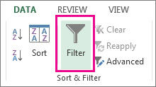
Filter a range of data
- Select any cell within the range.
- Select Data > Filter.

- Select the column header arrow .
- Select Text Filters or Number Filters, and then select a comparison, like Between.
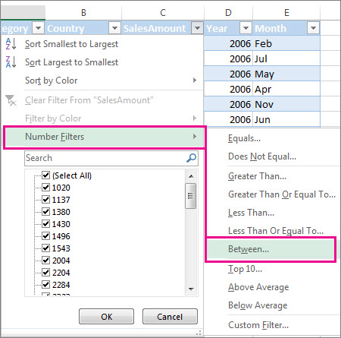
- Enter the filter criteria and select OK.
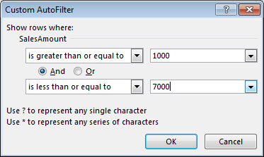

Filter data in a table
When you put your data in a table, filter controls are automatically added to the table headers.
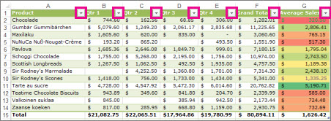
- Select the column header arrow for the column you want to filter.
- Uncheck (Select All) and select the boxes you want to show.
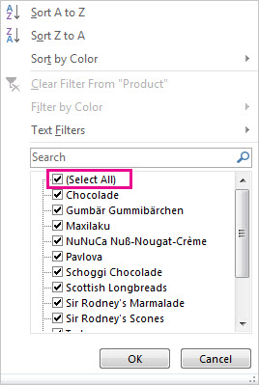
- Click OK.
The column header arrow changes to a Filter icon. Select this icon to change or clear the filter.

Add a Total row to a table
You can add totals to a table by selecting the Total Row checkbox on the Design tab. You can also add a function from the total row drop-down.
- Select a cell in a table.
- Select Design > Total Row.
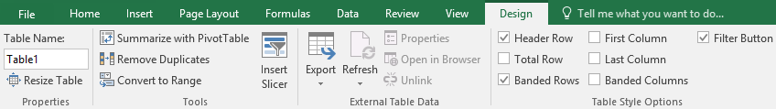
- The Total row is added to the bottom of the table.
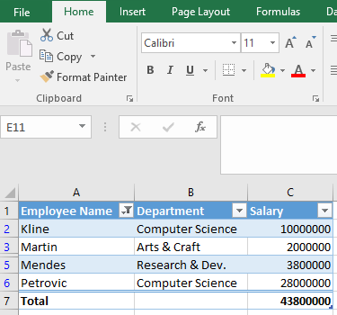
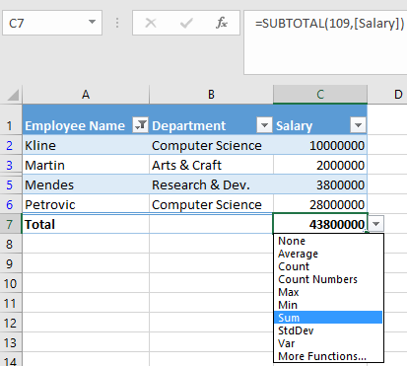
Note: To add a new row, uncheck the Total Row checkbox, add the row, and then recheck the Total Row checkbox.
- From the total row drop-down, you can select a function, like Average, Count, Count Numbers, Max, Min, Sum, StdDev, Var, and more.

Use slicers to filter data
Convert data into a table
- There are four ways to convert data into a table:
Note: In order to use a slicer, you must convert your data into a table first.
  - Press Ctrl + T.
  - Press Ctrl + l.
  - Select Home > Format as Table.
  - Select Insert > Table.
- Select OK.
Use a slicer to filter data
- Select Insert > Slicer.
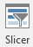
- Select the fields you'd like to filter.
- Select OK and adjust your slicer preferences, such as Columns, under Options.
Note: To select more than one item, hold Ctrl, and then select the items that you want to show. Select and hold the corner of a slicer to adjust and resize it.
- Select Clear Filter to clear the slicer filter.

